***HOME AUTOMATION AND BILLING SYSTEM***

**GROUP # 13**

**Members:**

* **Hassan Ahmed Khan (B21110006041)**
* **Sheraz Asghar (B21110006122)**
* **Muntazir Hassan (B21110006100)**
* **Saad Sami Khan (B21110006108)**
* **Qaim Hassan (B21110006105)**
* **Osama Ahmed (B21110006104)**

**Abstract:**

This project aims to enhance an IoT Energy Meter system using the ESP32 microcontroller and integrate daily electric appliance automation through the Blynk 2.0 application. The primary goal is to address manual meter reading inefficiencies by implementing real-time electricity consumption monitoring, emphasizing a seamless user experience for remote data collection and appliance control via IoT. The Smart Electricity Energy Meter employs advanced sensors—SCT-013 for current and ZMPT101B for voltage—to measure key parameters like voltage, current, power, and total energy consumption. Data is efficiently transmitted to the Blynk 2.0 app, providing users with immediate insights into their electricity usage.

Additionally, the project incorporates a Four-channel Relay in the Home Automation System, enabling users to actively manage up to four electrical appliances. A notable feature is the system's data continuity during power outages, achieved through EEPROM data storage in the ESP32. This ensures reliable readings, contributing to overall system reliability.

Aligned with the global trend towards automation, this initiative presents a sophisticated IoT-based solution for automated electricity consumption monitoring. The integration of innovative sensor technologies, dependable data storage methods, and a user-friendly interface positions this project at the forefront of contemporary advancements in electronic systems for home energy management. The fusion of cutting-edge technology with user-centric design principles promises a robust and efficient system, meeting the evolving needs of modern households. This project not only optimizes efficiency and reduces operational costs but also reflects a forward-looking approach in the realm of home energy management systems.

**LITERATURE REVIEW:**

1. GND is the Ground Pin of ESP32 OR the Ground pin of some sensor
2. Vin is Esp32 Voltage Pin
3. SCT-013 is the Current Sensor
4. ZMPT101B is the Voltage Sensor
5. D1, D2, D3, D4 …. are the pins of ESP32

**TABLE OF CONTENT**

|  |  |
| --- | --- |
| **TOPICS** | **PAGE #** |
| 1. Introduction    1. Background    2. Objectives    3. Scope    4. Significance 2. Hardware Detail    1. ESP32    2. Relay Board    3. SCT013    4. ZMPT101B 3. Circuit Design and Implementation    1. IOT Smart Meter    2. Home Automation 4. Software Design 5. Conclusion 6. References | 4 -5  4  4  4  4-5  5 -7  5  6  6-7  7  8-11  8-9  10-11  11-14  15  16 |

**INTRODUCTION:**

**Background:**

This project addresses the imperative for an advanced solution in electricity consumption monitoring and home automation, driven by the inadequacies of traditional manual meter readings. Recognizing the need for efficiency, the project integrates the Internet of Things (IoT) and the Blynk 2.0 application to usher in a more sophisticated approach.

**Objectives:**

The primary objective is to enhance an existing IoT Energy Meter system, employing the ESP32 microcontroller, and introduce automation for daily electric appliances through the Blynk 2.0 application. Key goals include achieving real-time electricity consumption monitoring, integrating state-of-the-art sensors for precise data measurement, and implementing a Four-channel Relay for active control of electrical appliances.

**Scope:**

This project encompasses the enhancement of the current IoT Energy Meter system and the integration of a Home Automation System utilizing ESP32 and Blynk 2.0. Specific functionalities involve measuring voltage, current, power, and total energy consumption through SCT-013 and ZMPT101B sensors. The Home Automation System facilitates the control of up to four electrical appliances via a Four-channel Relay, with considerations for potential limitations in the number of appliances controlled and the range of the IoT network.

**Significance:**

This initiative holds paramount significance in addressing the inefficiencies associated with manual meter readings by introducing automation to electricity consumption monitoring. The project offers a streamlined, user-friendly experience, coupled with remote data collection and control capabilities through IoT, aiming to optimize efficiency and reduce operational costs. Aligned with the global trend towards automation, it presents an opportunity to deliver a sophisticated IoT-based solution that caters to the evolving needs of modern households. The utilization of cutting-edge technology and user-centric design principles further underscores the significance of this initiative in the realm of electronic systems for home energy management.

**Existing Solutions:**

Existing solutions and technologies in the automation of electrical appliances and meter billing have evolved significantly. Leveraging advancements in IoT, smart home technology, and energy management systems, solutions range from smart home platforms like Amazon Alexa and Google Home to advanced smart meters with real-time monitoring capabilities. This project stands out by combining these technologies to deliver a comprehensive and efficient solution for modern energy management.

**HARDWARE:**

1. **ESP32:**

The ESP32, developed by Espressif Systems, is a highly versatile microcontroller and system-on-chip (SoC) renowned for its efficiency in IoT applications. Key features include a dual-core Tensilica LX6 processor for multitasking, built-in Wi-Fi and Bluetooth capabilities, a diverse set of peripherals, and low power consumption, making it ideal for wireless communication, home automation, and wearable devices. Security features like secure boot and cryptographic accelerators enhance device security, while advanced sleep modes enable energy conservation during idle periods. Its compatibility with the Arduino IDE simplifies programming, and the extensive community support ensures a wealth of resources for development. The ESP32 stands out as a cost-effective solution, making it a popular choice for IoT enthusiasts and developers working on a wide range of projects.

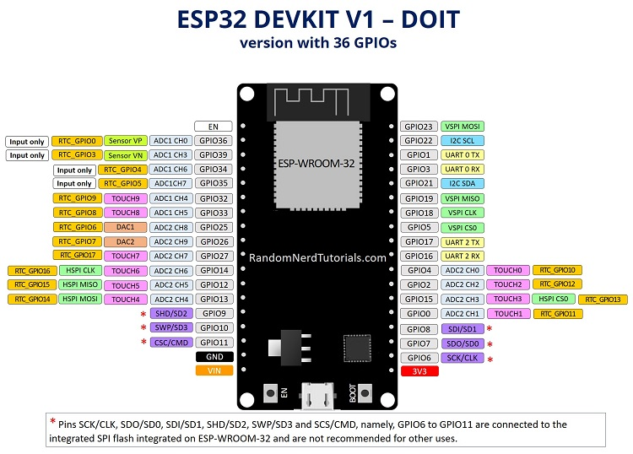

1. **RELAYBOARD:**

A relay board is an electronic device that uses low-power signals from microcontrollers or sensors to control high-power circuits or appliances. It incorporates electromechanical relays for switching electrical power, providing isolation between the low-voltage control circuit and the high-voltage load. Key characteristics include:

* + **Switching Functionality:** Employs relays to open or close circuits, controlling the power supply to connected devices.
  + **Isolation:** Ensures electrical isolation between the control and load circuits for enhanced safety.
  + **Channels:** Available in various configurations with specific input and output channels, receiving signals from microcontrollers and connecting to high-power loads.
  + **Control Signals:** Operates with low-voltage control signals, compatible with microcontrollers like Arduino or Raspberry Pi.

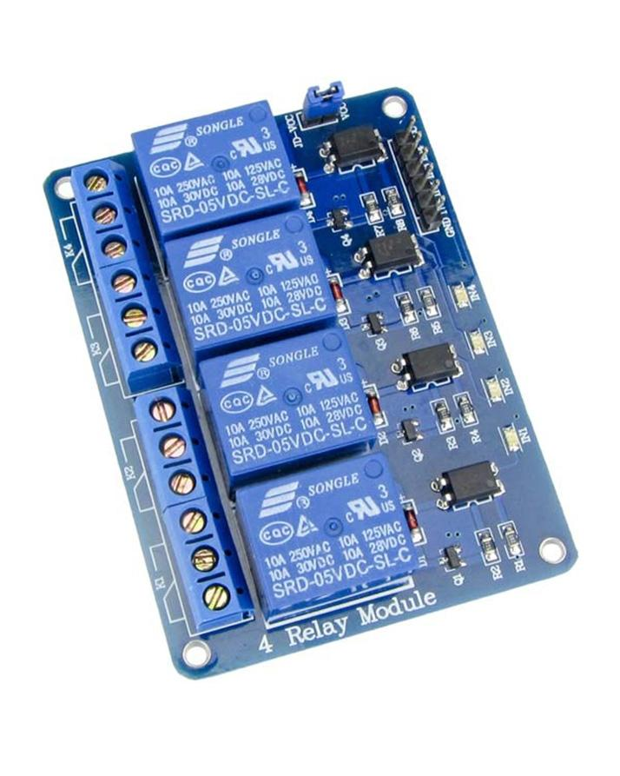

**3. SCT-013**

The SCT-013 is a split-core clamp meter sensor for measuring AC current up to 100A. Also known as a current transformer (CT), it offers non-invasive installation on live or neutral wires without high-voltage involvement. The sensor consists of primary and secondary windings enclosed in a transformer casing. Key specifications include:

* + Input Current: 0-30A AC
  + Output Signal: DC 0-1V
  + Non-linearity: 2-3%
  + Built-in Sampling Resistance (RL):** 62Ω
  + Turn Ratio: 1800:1
  + Resistance Grade: Grade B
  + Work Temperature: -25°C to +70°C
  + Dielectric Strength: 1000V AC/1min 5mA (between shell and output)



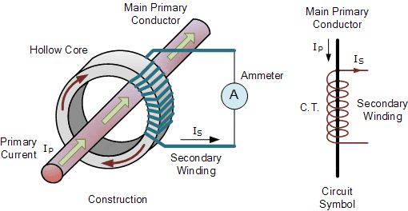

**4. ZMPT101B:**

The ZMPT101B AC Voltage Sensor Module is a high-precision device designed for accurate measurement of AC voltage in single-phase systems. Key features include:

* + Voltage Range: Up to 250V
  + Built-in Voltage Transformer: Utilizes a micro-precision voltage transformer for accuracy.
  + Adjustable Analog Output: Offers adjustable output using a multi-turn trim potentiometer.
  + Operating Temperature: Suitable for temperatures ranging from 40ºC to +70ºC.
  + Supply Voltage: Operates on a supply voltage between 5V to 30V.

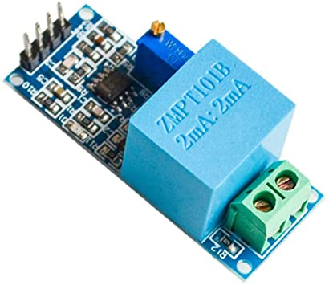

**CIRCUIT DESIGN AND IMPLEMENTATION**

**1) BILLING SYSTEM**

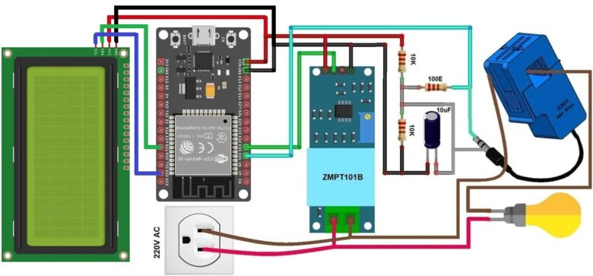

The above Circuit diagram is the is the Circuit Diagram for “Smart IOT Meter” In this we use Following Component:

1. SCT013 (Current Sensor)
2. ZMPT101B (Voltage Sensor)
3. ESP32
4. 16 X 2 LCD Display
5. 1 x 10µ Capacitor
6. 2 x 100K Ω Resistor
7. 1 x 100 Ω Resistor
8. 220v Ac voltage Source

**Circuit Description:**

Our circuit design integrates precision and functionality, utilizing a hybrid configuration for optimal performance. Here's a professional and concise breakdown:

1. **Resistor Network:**

* Two resistors, 100KΩ (Resistor 1) and 100Ω (Resistor 2), are ingeniously connected in parallel.
* This parallel combination is then connected in series with another 100KΩ resistor (Resistor 3).

2. **ESP32 Connectivity:**

* The VIN (Voltage Input) pin of the ESP32 is seamlessly linked to one end of Resistor 1.
* The GND (Ground) pin of the ESP32 is connected to the parallel arrangement of Resistor 3 and a capacitor.
* The other end of Resistor 3 is connected in parallel with a capacitor, creating a comprehensive circuit.

3. **SCT013 Current Sensor Integration:**

* The SCT013 Current Sensor becomes an integral part of the circuit.
* One end is parallelly connected with a capacitor and the resistor circuit.
* The other end is tactfully interfaced with the D34 pin of the ESP32.

4. **ZMPT101B Voltage Sensor:**

* VCC, GND, and OUT pins of the ZMPT101B Voltage Sensor are strategically linked.
* The VCC is connected to the VIN pin, GND to the GND pin, and OUT to the D35 pin of the ESP32.
* The sensor interfaces with a robust 220V input source through dedicated ports.

5. **16 × 2 LCD:**

* We attach LCD pins with following ESP32 pins

|  |  |
| --- | --- |
| **ESP32** | **LCD PINS** |
| D13 | RS |
| D12 | E |
| D14 | D4 |
| D27 | D5 |
| D26 | D6 |
| D25 | D7 |

6. **Functional Overview:**

* The resistor network ensures precise impedance matching and efficient signal flow.
* ESP32 acts as the control hub, efficiently handling voltage input and current sensing.
* The SCT013 Current Sensor provides accurate current measurements, enhancing overall monitoring capabilities.
* ZMPT101B Voltage Sensor seamlessly integrates with the 220V input source, enabling voltage monitoring with precision.

**2) Home Automation System:**

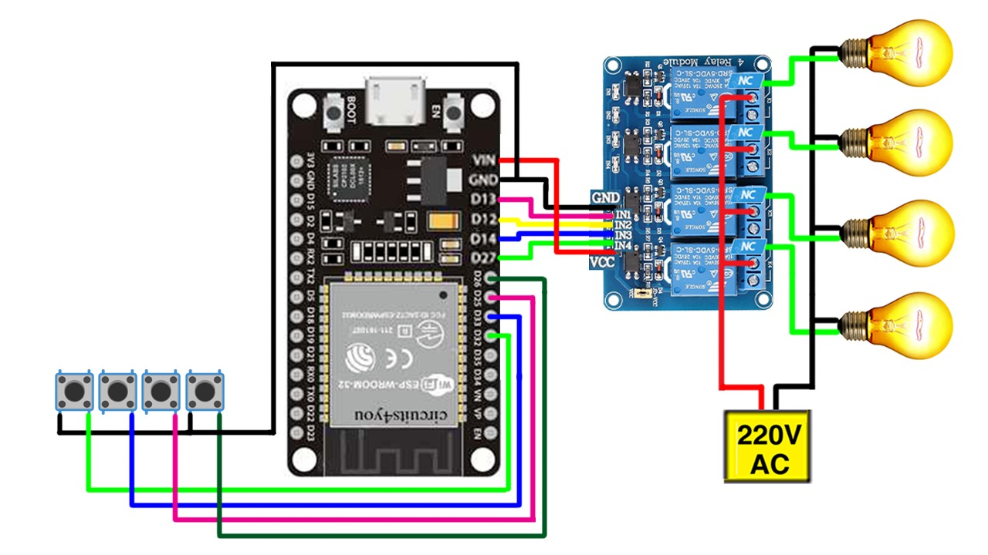

The above circuit diagram is to show the circuit Design of “Home Automation System” .Following are the Components:

1. 4 Channel Relay
2. 4 Switch buttons
3. 220v Ac voltage Source
4. ESP32

The relay module is seamlessly integrated into our ESP32 circuit design. The VCC and GND pins of the relay connect to the VIN and GND pins of the ESP32, establishing a reliable power source. The control inputs, "IN1," "IN2," "IN3," and "IN4," are tactically connected to Digital Pins D12, D13, D14, and D27 on the ESP32.

Simultaneously, the ESP32 features three ports, where the center port of each relay is connected in series. This series connection links to a 220V voltage source, ensuring a robust power supply. The first port (NC) of each relay is strategically wired to the desired loads—in our case, bulbs—facilitating efficient control of the connected devices. Additionally, a wire connected to the 220V source is also introduced in series with the loads.

Switch buttons play a pivotal role in our circuit. One end of each switch button is intricately connected to D18, D5, D33, and D32 pins of the ESP32, offering precise control. The other end of the switch buttons is judiciously linked to the GND (Ground) pin of the ESP32, completing the circuit and enabling seamless functionality.

This concise arrangement ensures an effective and organized control system, allowing the ESP32 to command the relay module and, consequently, manage the connected loads through the strategically positioned switch buttons.

This circuit design amalgamates accuracy, efficiency, and adaptability, making it an ideal solution for applications demanding meticulous control and monitoring.

**COMPLETE CIRCUIT DIAGRAM:**

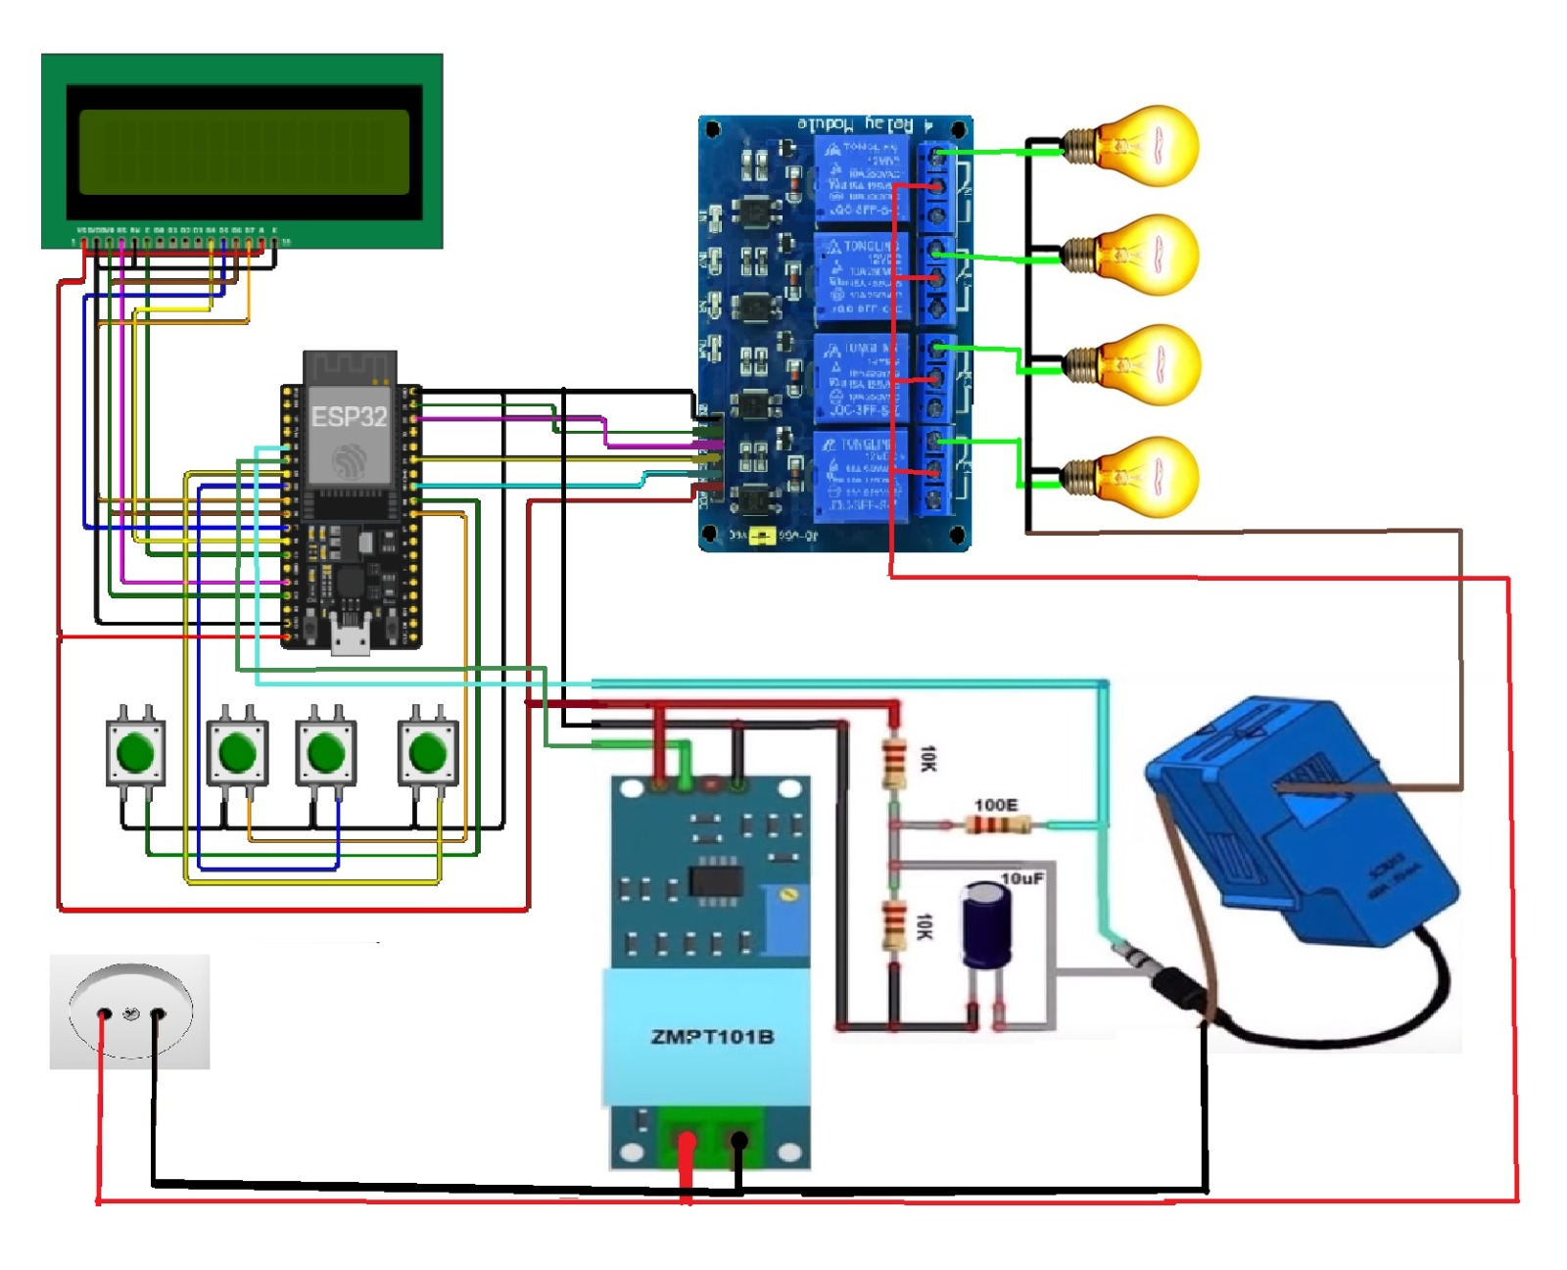

**SOFTWARE DESIGN:**

The program of our project is dependent on libraries which includes:

* Blynk
* WiFi
* WiFi Client
* Liquid Crystal
* EmonLib
* EEPROM

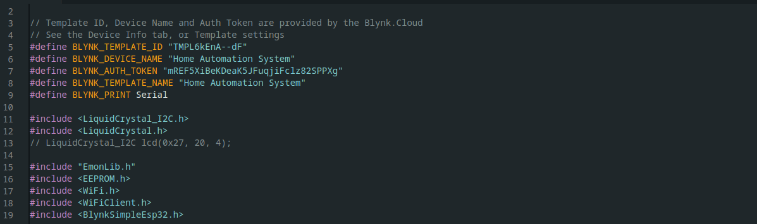

**DECLARATION:**

* All pins with their names and use cases are defined
* Instances of libraries are initialized
* WiFi credentials are provided and Blynk authentication is required

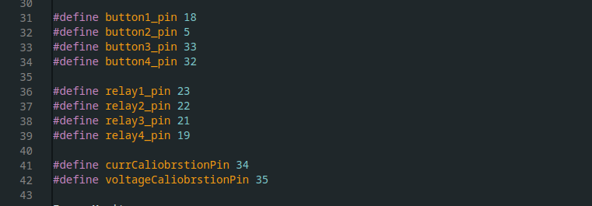

**FUNCTIONS:**

* **BLYNK_CONNECTED ():**

This function is responsible to ensure Blynk virtual pins are synchronized

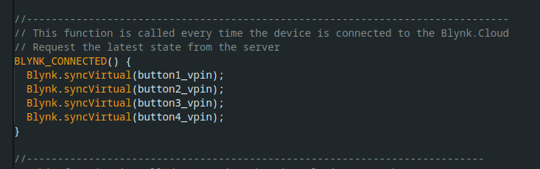

4

* **BLYNK_WRITE (Virtual Button Pin):**

This function updates the relay state when state is updated from website or Blynk App by checking whether the switch is ON/OFF.

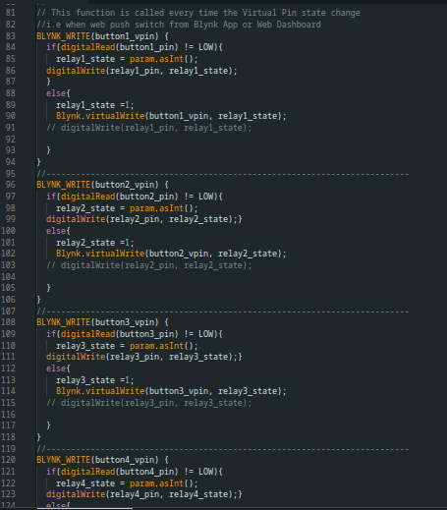

* **myTimerEvent ():**

This function calculates voltage (Vrms), Current (Irms), Power and Kilowatt Hour of a system being consumed and saves it in ESP’S memory. This function also displays the respective values on the LCD and updates them on the Blynk Server.

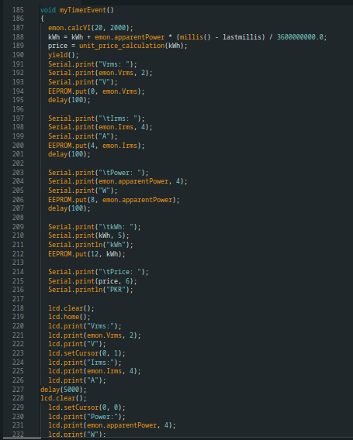

* **Listen_push_button():**

This function checks whether the switch is OFF and makes sure the light remains off

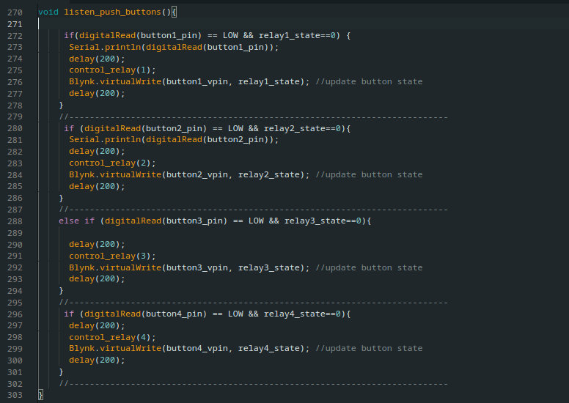

* **Control_relay ():**

This function update the state of particular relay depending on the switch

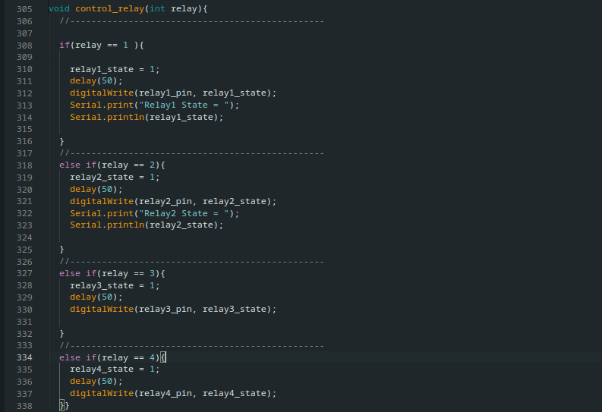

* **unit_price_calculation(float kwh):**

This function calculate the Price of the Electrical energy Consume by taking kwh value as input. It calculate price on the recent unit rate of K-Electric Pakistan

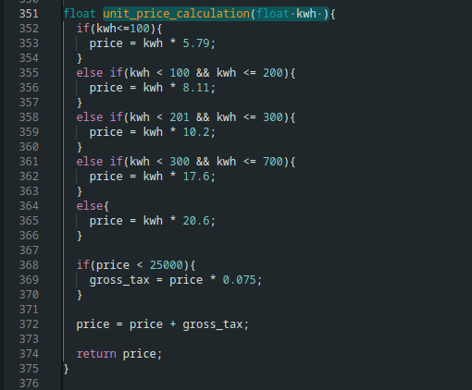

* **readEnergyDataFromEPROM():**

This function read Electricity Consumption Unit value

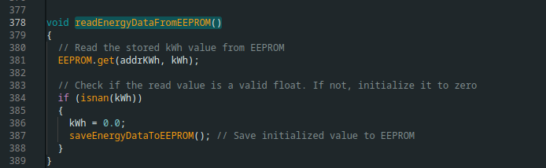

* **saveEnergyDataToEprom():**

This function store Unit value to save the used unit if in any case ESP32 crash or shutdown

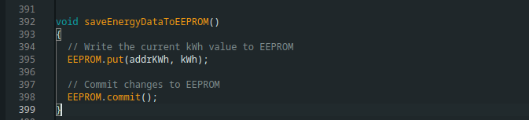

* **Setup ():**

This function defines purpose of the pins, Updates relay and virtual switch states depending on the state of physical switch It initializes Blynk with provided credentials.

* **Loop ():**

It starts Blynk with its timer and call Listen_push_button()

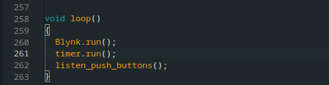

**Conclusion:**

This IoT-based Energy Meter and Home Automation System project utilizing the ESP32 microcontroller has yielded significant advancements in electricity consumption monitoring and control. The integration of cutting-edge sensors such as the SCT-013 Current Sensor and ZMPT101B Voltage Sensor enables precise measurements of critical parameters, including voltage, current, power, and total energy consumption. The incorporation of the Blynk 2.0 application facilitates real-time monitoring and control, adding a layer of convenience and accessibility for users. The Four-channel Relay in the Home Automation System extends the project's utility beyond monitoring, allowing users to actively manage and control up to four electrical appliances.

This project addresses the inefficiencies associated with manual meter readings, offering an automated and efficient solution for real-time electricity consumption monitoring. The user-centric design principles, seamless data transmission to the Blynk 2.0 application, and the ability to control appliances remotely through the ESP32 contribute to an enhanced and user-friendly experience. The robustness of the system, including data continuity during power outages through EEPROM data storage, ensures consistent and reliable readings, further underscoring the project's significance in modernizing home energy management systems.

In summary, this project not only advances the capabilities of home energy monitoring and automation but also lays the groundwork for future innovations in the field. The fusion of IoT technologies, smart sensors, and user-friendly interfaces positions this project at the forefront of modern electronic systems for efficient and intelligent home energy management.

**REFERENCES:**

**YOUTUBE:**

1. <https://youtu.be/H6wmBGExMJg?si=JcNH9_Xme5FOwILE>
2. <https://youtu.be/DshR6Y9aTSs?si=dpTDbnSDA_-xgUMY>

**WEBSITES:**

1. <https://how2electronics.com/iot-smart-electricity-energy-meter-with-esp32-blynk-2-0/>
2. [https://deepbluembe1dded.com/esp32-lcd-display-16x2-without-i2c-arduino/](https://deepbluembedded.com/esp32-lcd-display-16x2-without-i2c-arduino/)
3. <https://randomnerdtutorials.com/esp32-pinout-reference-gpios/>